**Experiment-5**

**Aim**: To design Smart phone controlled light system

**Apparatus**:LED,Bluetooth,wires,breadboard,Arduino

**Circuit**:

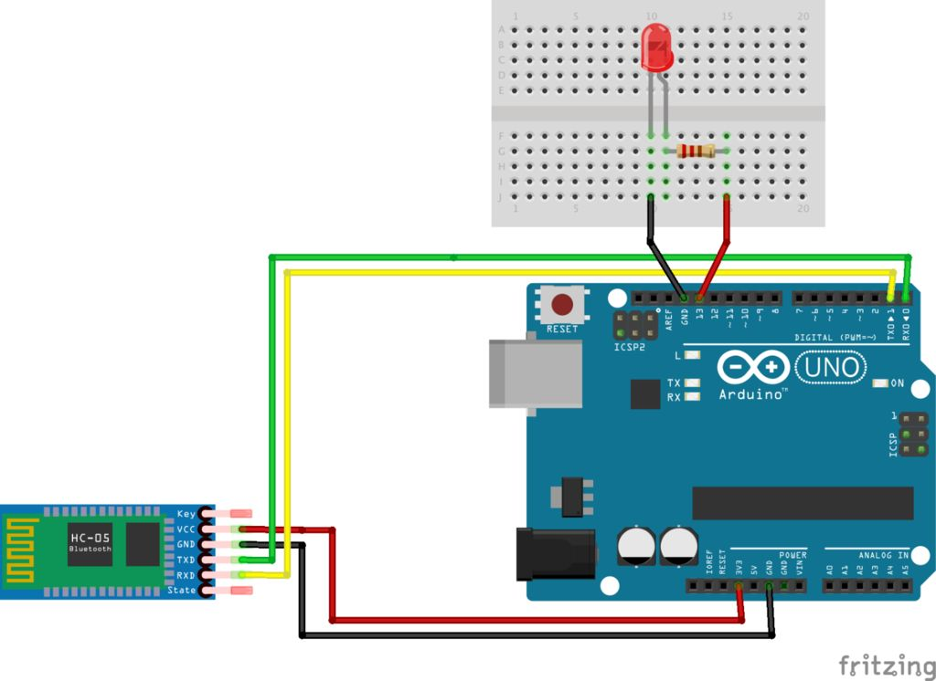

**Program**:

Char data=0;

Void Setup()

{

Serial.begin(9600);

pinMode(1,OUTPUT);

}

Void loop()

{

if(Serial.available()>0)

{

data=Serial.read();

Serial.print(data);

Serial.print(“\n”);

if (data==’1’)

digitalWrite(13,HIGH);

else if(data==’0’)

digitalWrite(13,LOW);

}

}

**LEARNING & OBSERVATION** :

1. We have to connect Bluetooth always with TX because it transmit the signal to arduino.

2. Arduino receives the signal from RX pin.

3. We have to connect three pin one with RX, other with TX and 5V.

**PROBLEM & TROUBLESHOOTING**:

1. Arduino may not work properly and cables can also create problem.

2. Mistake in code uploading.

**LEARNING OUTCOMES**:

1. Bluetooth always with TX because it transmit the signal to arduino.

2. Coding on arduino using bluetooth .

3. Speed of Bluetooth and inventions of new Bluetooth which works on higher speed and have